**Hypothesis 3: Heel wedges which negate the slope of uphill walking reduce metabolic cost while walking with a backpack load**

The aim of this section is to study how varying the outsole angle of footwear and treadmill incline while walking with a backpack load can affect the metabolic cost, joint kinematics, and muscle activity. We also hypothesise that the footwear angle which negates the slope of this treadmill incline will minimise the metabolic cost.

To vary the footwear angle, we aim to develop a shoe which varies the outsole angle without significantly affecting damping or bending stiffness. While varying these parameters could potentially affect GRFs and joint kinematics, we will focus only on the effect of the sole angle. We plan to use a conventional shoe with a completely flat outsole (Chuck Taylor All Star, Converse) of 3 different sizes (9.5,10,10.5 US) with hardboard wedges attached to the outsole. Grip rubber can be glued to the bottom to prevent slipping. Depending on the thickness of the hardboard, counter weights may need to be attached to the top of the shoe.

The treadmill angles used are similar to the prior two hypotheses, and the backpack load is set at 10% of the subject’s body weight. From previous research, we concluded that sagittal plane biomechanical parameters, namely ankle kinetics have the greatest effect on metabolic cost in uphill walking[] (since the variation of slope also occurs along the sagittal plane). The soleus muscle has been seen to have the highest energy expenditure[], thus EMG activity could potentially be used to relate metabolic cost to soleus muscle activity.

We will test 12 combinations of 3 different treadmill gradients and 4 outsole angles. The treadmill grade is expected to have a greater effect on the metabolic cost than the heel wedge, which is why an additional outsole angle is considered. The heel angles are selected based on our hypothesis that negating the slope will cause a decrease in metabolic cost. A positive incline of the treadmill, i.e. uphill walking is taken as positive, and the angles considered are 4°, 8°, and 12°. Heel wedges which negate this uphill slope are taken as negative angles and the values considered are -4°, -6°, -8°, -12°. (figure ##).

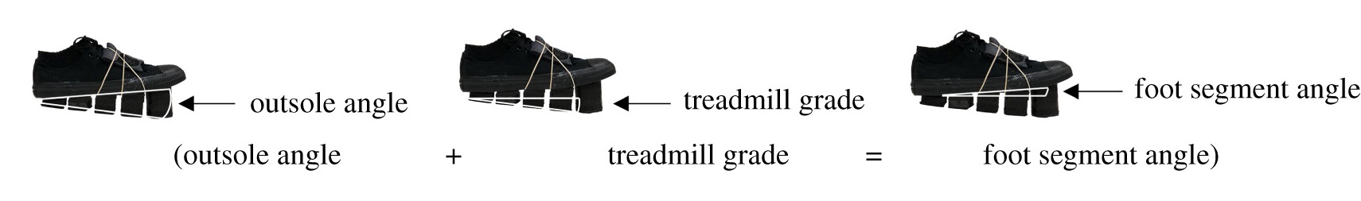

All trial values obtained during this phase will be compared against a baseline established similarly to hypothesis 1 to study the interaction of heel wedges while walking uphill with a load.

If we take the foot segment angle as the sum of the treadmill grade and the heel wedge angle (figure ##), then we expect to see the metabolic cost to be minimum when this foot segment angle is close to 0.